**HOSTING THE APP ON HEROKU - ASSIGNMENT 5**

**Report date:** 21/03/2021

**Batch code:** LISP01

**Version:** 1.0

**Intern:** Ajaegbu Ebuka Emmanuel

**Submitted to:** Data Glacier

**STEP BY STEP FOR MODEL DEPLOYMENT**

**Step One:** Create the Requirement.txt File

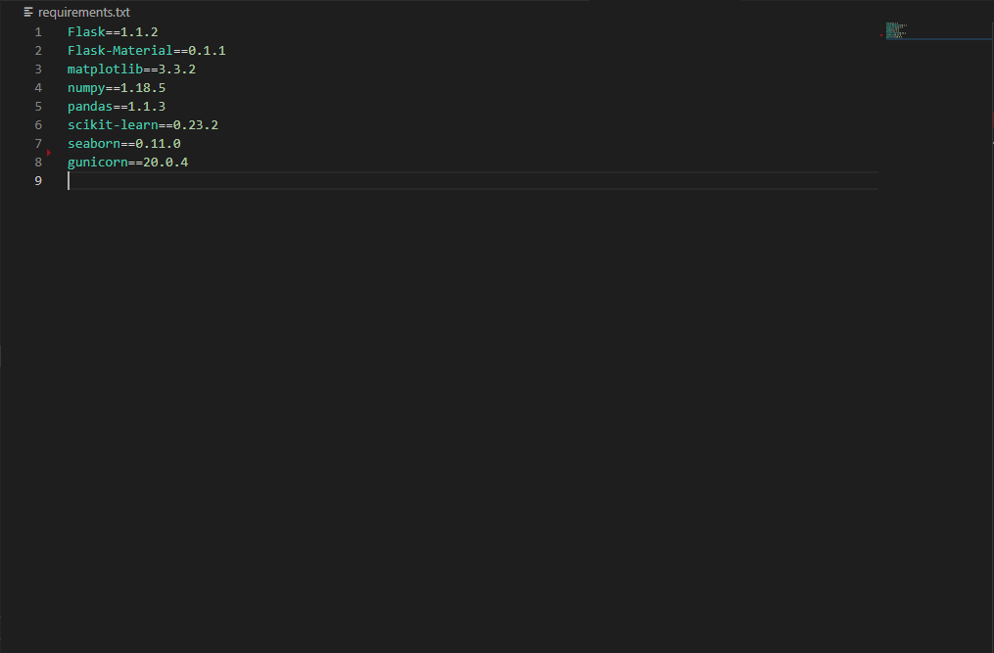

**Step Two :** Create the Profile- we use the Gunicorn Professional Web server

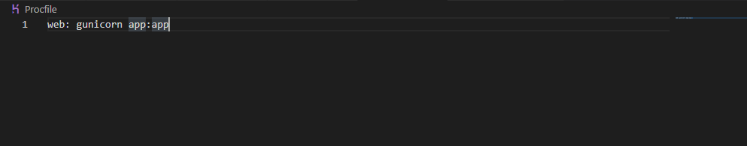

**Step Three :** Download Heroku CLI and Login to the Heroku

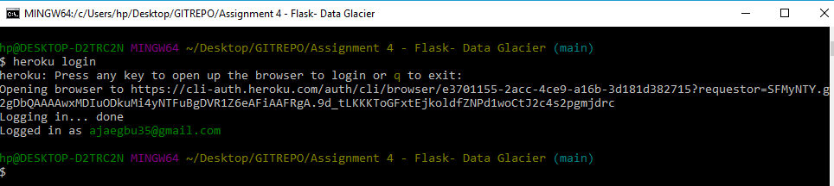

**Step Four:** Create a Heroku app and Rename It

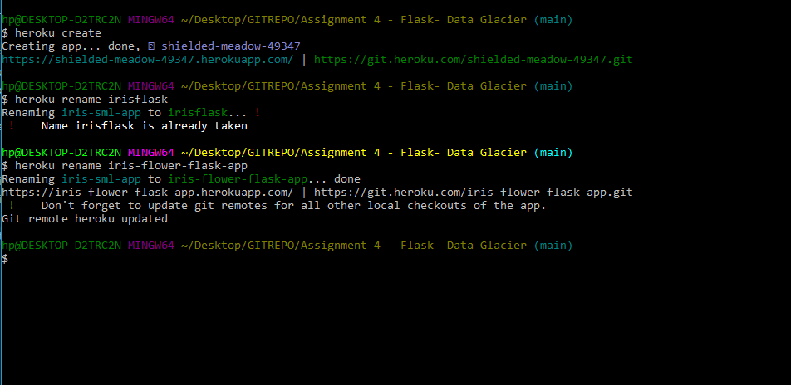

**Step Five**: Push Your Repo To Heroku

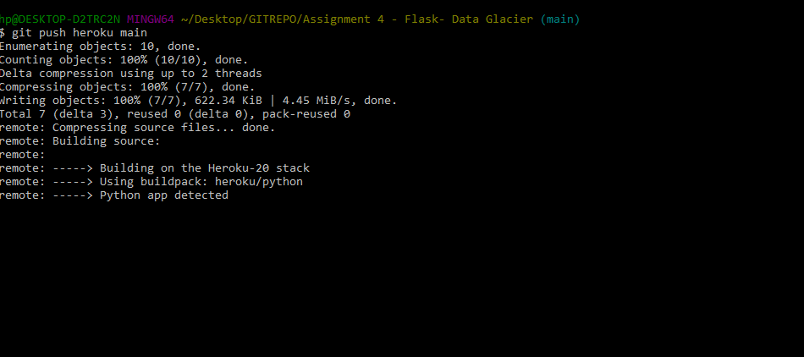

Successfully Craeted

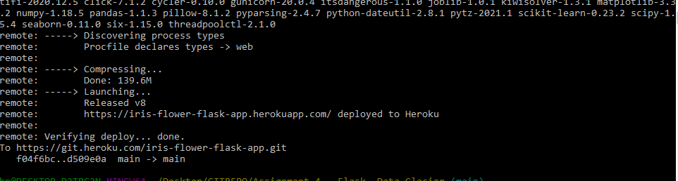

**Step Six:** View it on the web browser

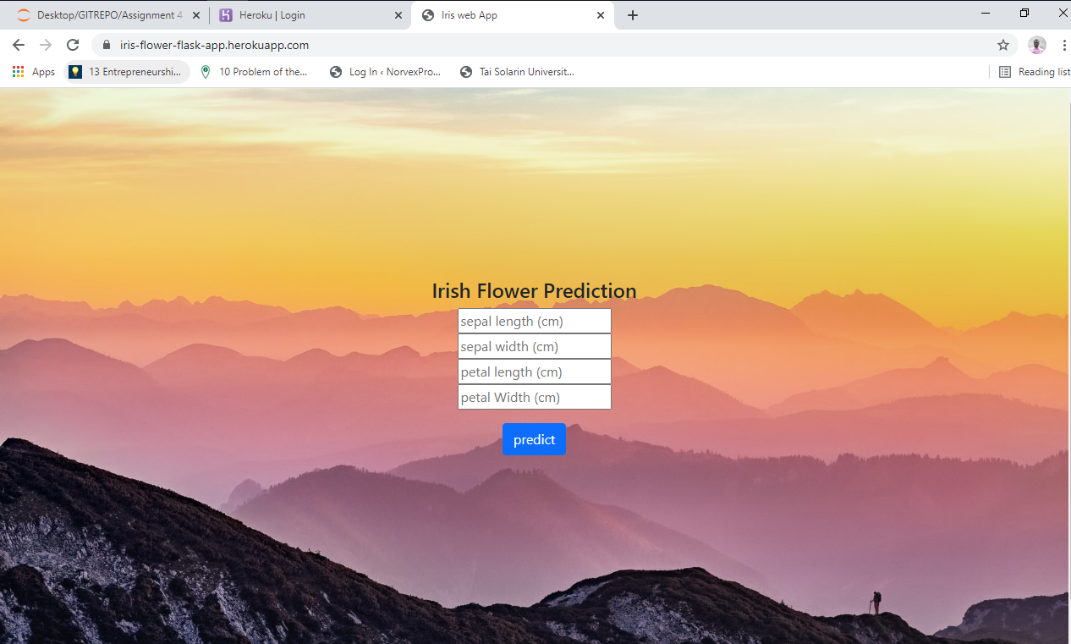

Link: <https://iris-flower-flask-app.herokuapp.com/>